Peninsula Clarion

Auction ready: 4-H club prepares for annual auction event
- By KAT SORENSEN
- Saturday, August 12, 2017 9:37pm
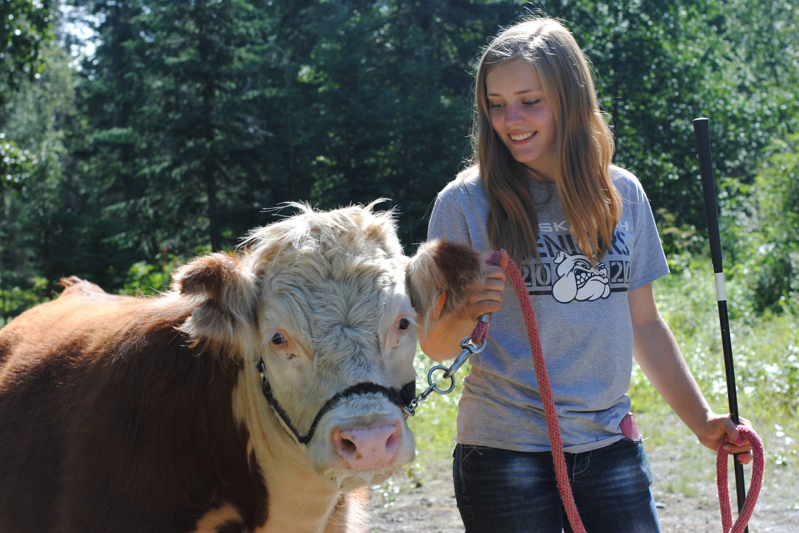

You must sign in or register to continue reading content.
Fair warning, don’t get in between two fighting pigs, according to Elora Reichert, a member of the 4-H Club and last year’s winner of the Master Showmanship for large livestock.
“Pig bites are not nice,” Reichert said as she led a large swine through a pen in a backyard in Nikiski on Saturday. “… And you have to try and keep up with your pig in an arena, with eight to 10 other pigs.”
The pig ran through the small group of 4-H students and their parents, with Reichert tapping the pig’s legs with a stick to lead it a certain direction.
“You never want to use the sticks on the hams, on the expensive part of the meat,” Reichert said. “And we’re tapping, not whacking. … The goal is to have the pig see the stick and go the way you want.”
After a few minutes of running the pig around, it plopped onto the ground.
The group debated how to get the pig back into the truck as they moved on to the next animal type, continuing the day’s lesson — how to properly show an animal at auction.
The Saturday showmanship demonstration was about more than showing off Reichert’s latest swine-tapping techniques. She was demonstrating to the 4-H group the best ways to show off their animals at the annual auction, which will be held at the Kenai Peninsula Fair in Ninilchik on Saturday.
“We have 4-H’ers who have been raising animals all year for the Junior Market Livestock Club,” Cassy Rankin, organizer of the North Road Rangers, said. “Having an animal in 4-H isn’t just about raising the animal.
“Showing the animal for a judge is an integral part of 4-H and the judges award a master showman in large livestock and a master showman in small stock.”
The North Road Rangers fall under the auspice of 4-H, which is a youth development organization focused on health, science, agriculture and citizenship, and work with the Junior Market Livestock Club to prepare 4-H students for the auction and other annual events throughout Alaska and the Lower 48.
“We teach the kids about safety, sustaining the land and learning as much as you can about raising animals,” said Christy Keerins of Homer, the Junior Market Livestock Club leader. “Then there is the reward of selling your animal and having that hard work pay off.”
Reichert is looking forward to showing her steer, Roy Rogers.
“For showing steer, you especially have to stay calm,” she explained. “I think they sense fear, because the first time I showed a steer I was really nervous and he didn’t like me. … They sense the world differently than we do.”
Reichert had been hoping for a steer her entire life, asking for one each time her birthday or Christmas rolled around.
“I fell in love with steers when I was 5 years old,” Reichert said. “So I finally got mine last year, and you want to show him off, you want to put your best foot forward, you want to set them up and groom them perfectly. It takes a lot of hard work, but it’s worth it.”
After a year with Roy Rogers, though, Reichert will say goodbye on Aug. 19.
“The day after he gets sent on the slaughter truck,” she said. “The next time I see him, he’ll be wrapped in plastic.”
But Reichert’s time with steer isn’t over. She’ll be bringing home Roy Rogers’ aunt from the auction to breed and continue her work with miniature steers.
Last year, Reichert took home the title of master showman in large livestock which includes steer, goat, swine, lamb and sheep. Colton Rankin was named master showman in small livestock, which includes chicken, rabbits, turkeys and guinea pigs.
“This year, I’m raising turkeys which I’ll be showing at the fair,” Colton said as he held a turkey in his arms, demonstrating the different techniques of showing the animal and the best way to flip the animal without eliciting an outrageous response.
“The showmanship for smallstock is a lot more involved because you’re moving them upside down and you’re showing the judges all the parts,” he said. “There is a lot more judge interaction.”
In comparison to years past, the 4-H Club has seen a decline in enrollment but Colton said he is hopeful there will be a large turnout at the auction.
“We really just hope that all the buyers go home happy,” Colton said.
Reach Kat Sorensen at kat.sorensen@peninsulaclarion.com

