- NEWS
- SPORTS
- OUTDOORS
- VALLEY HEALTH
- EVENTS
- E-EDITIONS
FEATURED

The Sandwich Project; Palmer High School student works to feed students in need
- By Jacob Mann Frontiersman.com

- Mar 22, 2019

- 1
- Facebook
- Twitter
- Email

Stay Informed. Subscribe For Only 99¢ per week

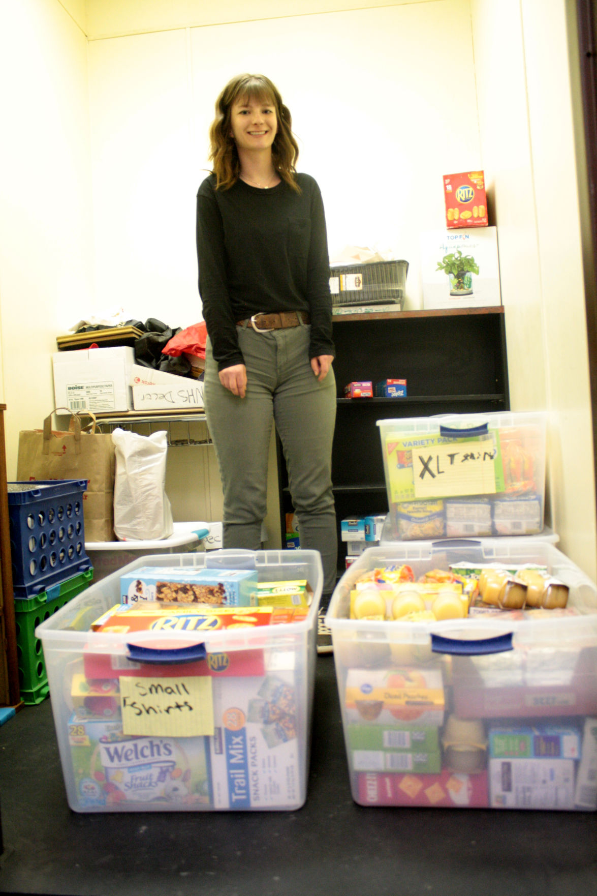

Palmer High School junior Zoe Nelles started the Sandwhich Project, which helps feed Palmer High students in need over the weekend.
- Jacob Mann/Frontiersman

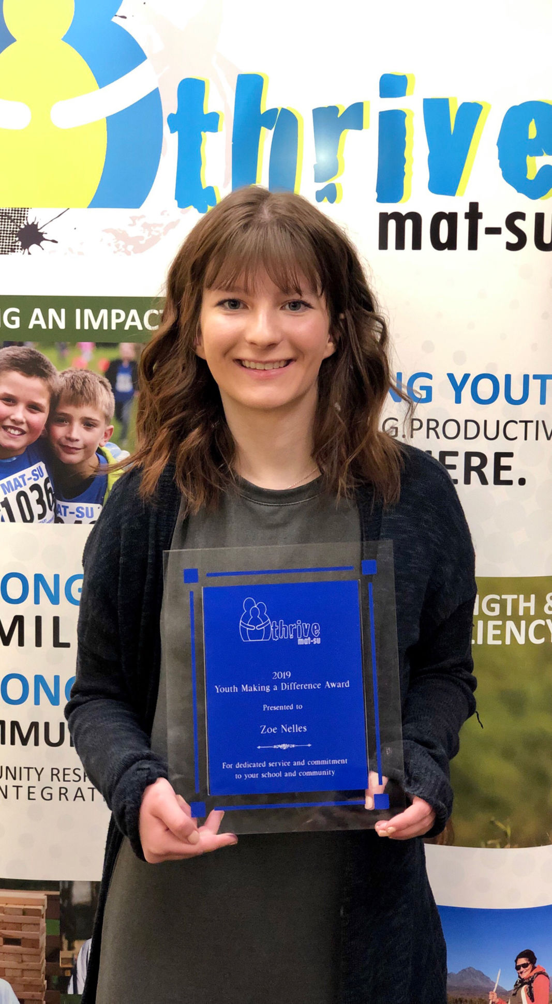

Palmer High junior Zoe Nelles was recently recognized by the United Way of Mat-Su for her work with the Sandwich Project.
- Courtesy photo

Palmer High teacher Sami King, left, and school nurse Carmen Pell, right, have helped Palmer junior Zoe Nelles, center, with the Sandwich Project.
- Jacob Mann/Frontiersman
- Facebook
- Twitter
- Email
- Print
- Save

PALMER — Public schools, such as Palmer High, have meal programs during the school day for those in need. But one Palmer High student saw an additional problem, and she stepped up to try to solve it.
With the help of Palmer High staff, junior Zoe Nelles started the Sandwich Project, an effort to feed PHS students in need over the weekend.
“I knew there was probably a need at Palmer High but I was just surprised to know there were that many students who I went to school with that didn’t have a reliable meal over the weekend,” Nelles said.
Nelles spends several hours each week gathering and preparing meals for fellow students. With her graduation just a year away, Nelles is doing what she can to make sure she isn’t the last PHS student to do this.
“She’s kind of a rare gem in the teenage world,” Palmer High school nurse Carmen Pell said.
Nelles said that she got the idea after seeing similar projects done at other schools like Wasilla High School. She said that prompted her to see where Palmer’s needs were. She approached one of her teachers, Sami King, who offered to help her supervise the project and store the food in her classroom.
The two went to Pell, who in turn, began identifying students in need. Nelles said that she served the first wave of students in October 2018. King and Pell have continued to support her project along the way.
“They’ve been a big help,” Nelles said.
Nelles said that once the project was underway, she was surprised how much of a need there really was. She said that even the initial amount, about seven students from October 2018 surprised her. She said that there are currently 22 students in the program and growing.
“We are reaching out to more students and are finding a bigger need as time goes on,” Nelles said.
As Pell finds the students who are in need and want to participate, Nelles prepares the meals in brown paper bags and brings them to her Friday mornings. There are no names or special indications on the bags since this whole process is deigned to be discreet and confidential.
“She doesn’t know them and they don’t know her,” Pell said.
Public schools like PHS have meal programs for students in need, offering breakfast and lunch at the school throughout the week. Nelles said that the Sandwich Project is there to help them with food on the weekends.
“I provide a good amount of food but it’s not enough for three meals each day but I like to think it lets the kids know someone’s thinking about them,” Nelles said.
Nelles said that she’s served an estimated 300 meals so far. King said that was a conservative estimate.
Nelles said that she held a food drive before spring break at PHS and it went well. She said that she got a lot of food out of it. She said one class brought in three big tubs of food and teachers continue to bring in donations throughout the week.
Nelles said that she doesn’t accept any canned foods because, “no kid really wants to eat a can of peas or something.”
She said that she provides a lot of snack foods like chips, granola bars and pop tarts. She regularly makes peanut butter jelly sandwiches, hence the name of the project.
“I like to do ramen because it’s hot and every kid can make that,” Nelles said.
This project seems to have picked up a good amount of momentum since Nelles now has additional support from PHS faculty. She said that the home economics instructor recently started having her teacher assistants making the sandwiches Friday mornings. Nelles said that’s been a great benefit since she was spending about an hour and a half each night to make the sandwiches.
“That can continue throughout the years and hopefully we can identify more students or reaching out to more students so that no kid’s left without a meal on the weekends,” Nelles said.
Pell noted that PHS has two preschool classes and they serve those classes as well. She said that they’ve also provided meals for middle school students and their siblings in the elementary schools in the Palmer area.
“Not all of the meals go to Palmer High students but they serve our Palmer community,” Pell said.
Nelles said that they were approached to start expanding the program to elementary schools. She said that she really likes the idea but she wants to focus on making here initial project sustainable with its own legs first.
Nelles does not want this project to fade away after she graduates. She said that she wants it to be sustainable and ongoing project; and she is working to establish a club or group of students to participate and keep the momentum going. King and Pell both sang Nelles’ praises, commending her for her work ethic, compassion and overall vision- a rarity amongst teenagers.
“One of her main concerns is when she graduates, that since she’s a junior, she’s really working hard to make sure this is a sustainable program that we keep long after she’s gone, I’m retired,” King said. “There just aren’t kids who have that vision.”
Nelles recently received a scholarship from the United Way of Mat-Su for her philanthropic efforts with the Sandwich Project. King noted that they’ve also put in some grants and waiting to her back on those. Nelles said that she is also looking to host fundraisers in the near future.
Anyone Interested in helping Nelles provide weekend food for Palmer High students in need can help by donating to The Sandwich Project or contributing nonperishable food and related items like peanut butter, jelly, bread, individually packaged snacks, plain brown-paper bags, and plastic baggies. Donors are asked to avoid donating canned food and homemade dishes.
Teens or families in need of food assistance on the weekends, are encouraged to contact the PHS school nurse, Carmen Pell, at (907) 746-8438 or carmen.pell@matsuk12.us. All participation is completely confidential.
Contact Mat-Su Valley Frontiersman reporter Jacob Mann at jacob.mann@frontiersman.com

