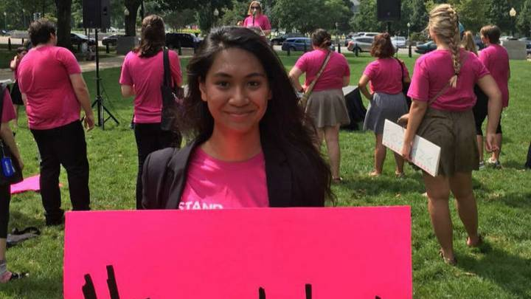
Tasha Elizarde MTV FOUNDERS
THE POWER OF UNDERSTANDING YOUR BODY
I WENT FROM KNOWING NOTHING ABOUT SEX TO BECOMING A SEX-ED ACTIVIST
TASHA ELIZARDE 09/13/2016
I was steps away from U.S. Sen. Murkowski’s office, prepared to discuss the importance of sexual health education access in Alaska. Then I started crying. Our meeting was minutes away, but I could feel unwelcome anxiety rising in my throat, choking me. My hands gripped to the handrails of the stairs I was climbing. I felt my legs trembling and it was difficult to breathe.
On July 23, 2016, I flew from Alaska to Washington, D.C. for the first ever “Lift As We Climb” Teen Council Summit hosted by the Peer Education Institute and Planned Parenthood Generation Action. I decided to join Teen Council, a Planned Parenthood–run peer sex education program, because of my own need for sexual health information. Growing up, I learned very little about my body — I had not even known about menstruation until I got my period for the first time, and I was revolted at my body and the completely natural things that it did.
As drastic as that sounds, I am hardly the only teen in this sort of situation. According to the Alaska Department of Health and Services and the Center for Disease Control, Alaska leads the nation in sexual abuse and rape and has the highest chlamydia rate in the country. Less than a quarter of Alaskan schools taught the recommended HIV, STD, and pregnancy prevention topics during the 2013–14 school year, beating all but three other states for lack of access to sex education.
Teen Council works hard to make sure that marginalized teens in Alaska and the country receive the information they need to prevent these statistics from rising. At the Teen Council Summit, over 150 Teen Council members from all over the nation gathered to network, exchange resources, learn about reproductive and racial justice, and strengthen our voices for positive change — all to reach this goal. An additional, crucial part of this summit was the opportunity for each Teen Council member to speak with their state representatives on Capitol Hill about their passion for sexual health education.
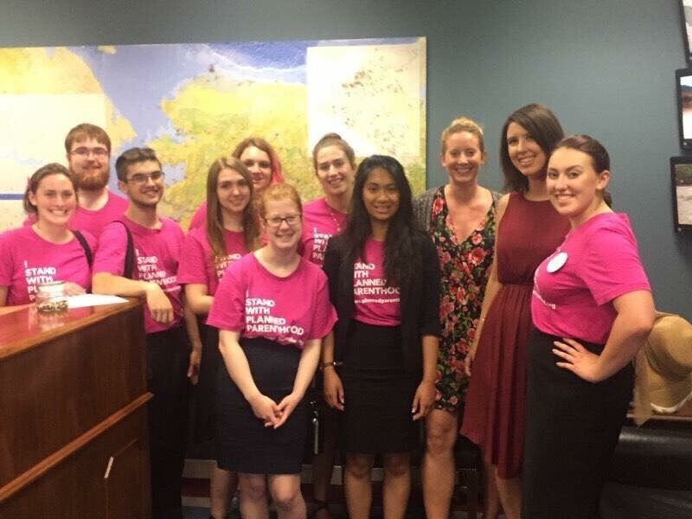
But when that moment finally came, I felt helpless — a feeling that not so long ago was all too common for me.
I had always been the shy kid who sat as close to the classroom door as possible, afraid to do so much as raise my hand for fear of judgement from my peers. One time, during my freshman year of high school, I was asked to simply stand up in front of my science class. This small act made me shake so hard that my teacher told me to sit back down. The kid sitting next to me had to pull me back into my seat and repeat what the teacher had said.
Now, after my first year in Teen Council, little things like this don’t bother me anymore. While at the summit, three other Alaskan teens and I led a workshop on community organizing, and although I still shook during my portion of the presentation, I did not freeze. After five minutes, I was speaking to the crowd with ease and purpose.
This transformation has been a direct result of my work with Teen Council, which has quickly become a place where I can speak up without being overtaken by fear. Every time I chose to do something new, I have been supported by the Teen Council community and by my new friends. When I testified for the first time against a legislative attack on sex education, the rest of my Teen Council cheered me on from their seats. When I crafted my first op-ed about access to sex education, my Planned Parenthood Regional Field Organizer reviewed and critiqued my writing. Every time I’ve taught a sex education lesson in my community, as Teen Council has trained me to do, my facilitator has been there, poised and ready to jump in if I ever found myself at a loss for words.
Teen Council’s impact extends beyond me, too. Every day I see the impact it has on my friends and family. After I taught my friend about dysmenorrhea, she talked to her doctor to see if her extra-powerful menstrual cramps were a side-effect of the disorder. Another time I directed a different friend to our school’s Teen Health Center because she couldn't afford birth control. In the spring, I saw our empowering effect again when almost 30 teens from all three of Juneau’s high schools came together to rally against an atrocious legislative attack on sex education. There were so many teens, most of whom had never participated in the political process before, who came because they believed strongly in their right to sex-ed. At the time, I was stuck in bed with a migraine, but as I followed the updates on social media, I cried tears of joy at our community’s strength.
It is because of these moments — the sense of relief one gets when they finally understand their body, the strength one garners from fighting for something they believe in — that I continue my work as a peer educator. Back at the Capitol, inside one of the most powerful buildings in the world, I had tricked myself into believing I was weak. But looking back at all of my growth — both personal as well as through my impact on my community — I know that is not true. Although I was not able to overcome my fears in that exact moment to speak to the senator, I know that being a Teen Council member has emboldened my voice, and I am proud to speak up for sexual education access across the country.

About the Author:
Tasha Elizarde is a high school Senior from Juneau, Alaska. Along with writing for her local newspaper, the Juneau Empire, and working alongside Planned Parenthood to provide sex education to her peers, she also enjoys learning with her Academic Decathlon team, advocating for Juneau youth, taking photos

Source: http://www.mtv.com/news/2931188/the-power-of-understanding-your-body/

