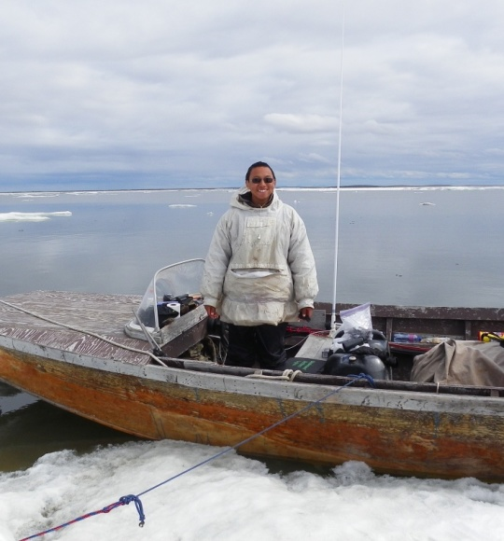
ESAU SINNOK
SHISHMAREF, ALASKA
Esau Sinnok is from Shishmaref, Alaska and is an Iñupiaq Eskimo. Esau is currently a youth organizer for 2015-2016 campaign for the Alaska Youth on Environmental Action, a program of the Alaska Center for the Environment. Esau is also an International Delegate for Sierra Club. Esau loves to go hunting, fishing, and camping with his family. Esau’s future hopes are to hold a state office position like Governor, or Senator, or Mayor after he graduates from University of Alaska Fairbanks.

