- Peninsula Clarion Newspaper, Kenai, Alaska

Pet projects

Students raise money to help local animals
Posted: April 20, 2014 - 9:47pm | Updated: April 20, 2014 - 9:51pm
Back | Next
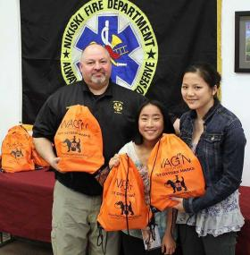
Photo courtesy Denise Cox Marguerite and Evangeline Cox pose with Nikiski Fire Chief James Baisden at the Nikiski Fire Board meeting on April 16. The two girls, sophomores at Nikiski High School, donated 12 pet oxygen masks to the Nikiski department and seven to the Kenai Fire Department.
By DAN BALMER
Peninsula Clarion
Two separate community service projects in Kenai and Nikiski have a couple things in common; both ideas originated from students and were directed to help make a positive impact in the lives of pets.
Two sophomores at Nikiski High School raised $1,500 to buy 20 emergency pet oxygen mask kits and donated them to the Nikiski and Kenai Fire Departments. Cousins Marguerite and Evangeline Cox presented 12 kits to the Nikiski Fire Department at their board meeting April 16.
Marguerite and Evangeline Cox wanted to ensure first responders were prepared with life-saving equipment for everyone in a household – pets included, said Denise Cox, Evangeline’s mother. After doing a little research, the cousins found an organization that sells oxygen mask kits intended for pets.
The two girls contacted all the fire stations in the central peninsula about the pet masks and raised money through bake sales in Nikiski at the craft fair and M&M Market, Denise Cox wrote in an email.
“When a fire breaks out, the first thing an animal usually does is to hide in fear,” Denise Cox said. “When a firefighter discovers an animal in distress, (the pet) usually needs immediate help and there is often little to no time to call a vet or shelter to receive help.”
The specialized masks, purchased through Wag’N 02 Fur Life for $75 each, come in three sizes designed to fit small animals and large dogs. The girls earned $900 from the bake sales and used their permanent fund dividend as well as received donations from family and friends to buy 20 kits, said Lindy Cox, Marguerite’s mother.
The two girls stuck with the project, even though their teacher informed them a community project wasn’t required for the class, Lindy Cox said.
“They are compassionate girls and worked so hard to raise enough money,” she said. “We are so proud of them. The response from the community was incredible.”…

