|  |  |
| --- | --- |
|  | East High School Robotics TeamC/O Heather Roach 4025 E. Northern Lights Boulevard Anchorage, Alaska 99508-3599  907.742.2100 Tax ID *# 92-600007* |

**Will You Help Future Alaskan Engineers Represent Alaska in Australia??**

**East High School Robotics Team 3360 is proud to be one of only 53 international robotics teams invited to the 2015 FTC Asia Pacific Invitational Tournament in Sydney, Australia. We cannot wait to represent Alaska and the United States, but we need your help to get there.**

**How can you help Team 3360 get to the Asia Pacific Invitational Tournament in Australia?**

Robotics Team 3360 is asking for a **tax-deductible** donation from you. There is no school funding for opportunities like this. We must raise every penny we need to get to the Tournament ourselves.

**What will you or your company get out of your tax deductible donation?**

**Team 3360 will sing for their supper!**

* We can put your name or your company’s logo on our robot, team t-shirts, team poster, team banner, and our Facebook page as one of our sponsors.
* We can also put on a demonstration of our robot at your office, as well as show you video footage of the state and world competitions from past years.
* We can explain the FIRST program to your office and tell you how our experiences have helped shape our lives.
* One member of Team 3360 can **volunteer** to work in your office for one day as thanks for your contribution.
* We can make arrangements for you to come to East High School after school hours to see our robot and meet us in person.

**How will my donation be used?**

Your donation will pay for plane tickets, lodging, meals, parts for the robot, and the general expenses for our trip to Australia. We accept cash, checks, complimentary hotel rooms in Sydney, and airline miles.

**Who is East High School Team 3360?**

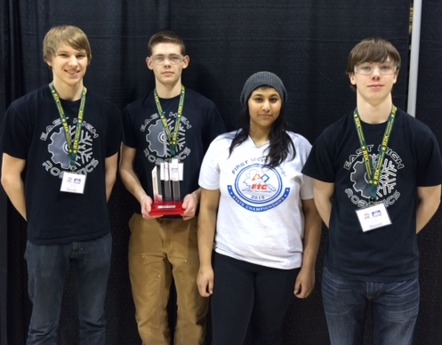

**Brandon Adkins** –a senior with four years’ experience in FIRST Tech Challenge who will study engineering next fall at UAA.

**Gabe Conkel** –a senior with four years’ experience in FIRST Tech Challenge who will join the military or study engineering next fall at UAF.

**Nada Hossain**—a senior with three years’ experience in FIRST Tech Challenge who plans to study biology.

**Austin Dabbs** –a senior with four years’ experience in FIRST Tech Challenge who will study engineering next fall at UAF.

**What is special about East High School Team 3360?**

* East High School Team 3360 has maintained a tradition of excellence since its inception in 2009.
* Our robots are built and programmed exclusively by us, and we are diligent workers on an award winning team.
* Accomplishments during the past three seasons:

Rockwell Collins Innovate Award (for Robot design/engineering)

Inspire Award Winner

Connect Award Winner

Promote Award Winner

First Regional Qualifier: Finalist Alliance (Second place) - First pick

Second Regional Qualifier: Finalist Alliance Captain

AK FTC Championship: Finalist Alliance -First pick

Alaska State Championship: Semi-Finalist

Second Regional Qualifier: Second Place Inspire Award

First Regional Tournament: Third Place Inspire Award

AK Championship: Finalist/Alliance Captain

* We also involve ourselves in our community with numerous outreach projects including mentoring elementary and middle school students involved in the FIRST Lego League Challenges.

Outreach/Community Events for this season:

East High Freshmen Fair Presentation to incoming freshmen

East High FTC Kick-Off Event for the current season

CRW Engineering, LLC Demonstration & Presentation about FIRST

Roger's Park STEM Night Presentation & Demonstration

FIRST Lego League Kick-Off Volunteers

FIRST Lego League Qualifying Tournament Volunteers

Sherrod Elementary Presentation for Engineering Week

ASTE Conference - Demonstration & Presentation about FIRST

Engineering Banquet - Demonstration & Presentation about FIRST

**Will you please help us?**

Name ___________________________________________________________________________

Address __________________________________________________________________________

City __________________________________ State __________ Zip _____________________

Amount of Donation: $_______________________________

___ I am interested in donating miles to the team. Frequent Flyer Program ____________________

___ I am interested in donating free hotel rooms to the team. Hotel Chain ____________________

I am interested in:

___ sponsorship recognition for my donation ___ a volunteer for one day of work

___ a robot demonstration at my office ___ a presentation on FIRST programs for all ages

___ a visit to East High School to see us at work

**If you have questions, please call or email our sponsor, Ms. Roach. Thank you!**

**Heather M. Roach, National Board Certified Teacher of Chemistry**

**907.250.3779** [**Roach_heather@asdk12.org**](mailto:Roach_heather@asdk12.org)